Stock analysis of alphabet inc and apple inc

# Introduction

Stocks are regarded as one of the most well-liked assets for investors in the world of investing. With the emergence of technology firms, investors seeking investments with strong growth potential are increasingly turning to tech equities. Apple and Google are two of the most well-known tech businesses, and they have long attracted the interest of investors.

This stock analysis’s main goal is to learn more about the stock performance of Google and Apple. We seek to assess the present condition of these stocks and forecast their future performance through the examination of their financial statements and market trends. Investors will benefit from this analysis when they choose which equities to buy.

With strong growth in revenue and profitability, Google's stock has been among the best-performing equities in the technology industry in recent years. Google Inc. has a market valuation of more than $1.5 trillion as of March 2023. In addition, Google's stock has historically been known for its stability and strong long-term performance.

While as Apple’s stock has a market valuation of over $3 trillion as of March 2023, and is one of the most popular and actively traded equities in the world. It has sustained revenue growth and profitability, Apple has a long history of excellent financial success. Apple and Google are the two companies that are primarily in charge of the dissemination process. Apple modified its privacy policy and restricted the capability of app developers to target users

Even Google also used ad targeting to connect advertisers with users on many of its properties; however, search advertising is a unique advantage because users tend to "self-target" as they are entering a search question that describes exactly what they are interested in at that particular instant in time. Google uses ad targeting to connect advertisers with users on many of its properties. Ad targeting is a method that Google employs across many of its properties to bring together advertisers and consumers.

Because Android is the most widely used operating system in the world, Google is able to dictate its own policies when it comes to advertising because it is in complete control of those policies. In spite of the fact that iOS distribution is still essential to Google's business, the relationship that the company maintains with Apple is closer than the one it has with Facebook. Google agrees to make yearly payments to Apple totaling billions of dollars in order to maintain its position as the default search provider for users of Apple's Safari web software.

Facebook has just disclosed to Wall Street that the social media company anticipates suffering a loss of $10 billion in revenue this year as a direct result of Apple's recently implemented App Tracking Transparency (ATT) feature. When all factors are taken into consideration, this news comes as a surprise. This was a significant contributor to the fact that the business did not reach its revenue predictions for the first quarter. It was also a significant contributor to Thursday's precipitous decline of 25% in the stock price. This was the single-worst day in the history of the stock's decline, and it dropped to a level that hadn't been seen since August 2020.

In the meantime, Google published spectacular results for the fourth quarter earlier this week on the back of a 33% rise in ad revenue. This compares to the 20% increase in advertising revenue that Facebook experienced during the same time period. Analysts anticipate that Alphabet, the parent company of Google, will achieve a growth rate of 23% in the first quarter

On Wednesday, the Chief Financial Officer of Facebook parent company Meta, David Wehner, stated that "the motivation obviously is for this policy discrepancy to continue" during a conference call with investors from the industry. This was in reference to the fact that as a consequence of the agreement with Google, Apple treats search more favorably than it does other applications.

# Financial Ratios

## Current Ratio

## Debt/Equity Ratio

## Return on Equity

## Earnings before interest and tax margin

## Gross Margin

## Net Profit Margin

# Performance analysis

The weight of the portfolios that we wanted to analyze are 0.6 and 0.4 for Apple Inc and Alphabet Inc (Google) respectively. And for analysis we wanted to use $15000 for test trading to know Risk and Estimated Short at a 99% confidence rate.

* Portfolio risk is 0.2916512
* Value at Risk for Apple is $674.8289 at 99% confidence
* Expected Shortfall for Apple is $780.2052 at 99% confidence
* Value at Risk for Alphabet is $704.9141 at 99% confidence
* Expected Shortfall for Alphabet is $815.9144 at 1% confidence
* Annualized Returns Apple: 0.8035289%
* Maximum Drawdown Apple: 0.3034915
* Annualized Returns Google: 1.337716%
* Maximum Drawdown Google: 0.4460185
* Sharpe Ratio Apple: 0.02604688
* Sharpe Ratio Google: 0.04148693
* Kelly Ratio Apple: 0.29115
* Kelly Ratio Google: 0.313259

# Technical analysis

## apple inc

Apple Inc despite being one of the largest companies in the market, the stock price of the firm has undergone frequent fluctuations in the market. The price has kept changing, but when compared from the start point of 2021 and end point of 2022 the stock price has grown. The RSI of Apple is 37.458 i.e. greater than 35. MACD has recently negatively crossed the signal line, the present value of MACD being -3.215 and signal line being -2.599. And William %R is 0.832.

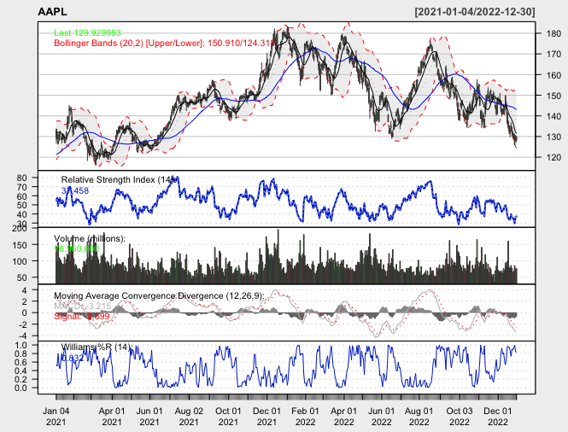

## ALPHABET INC

Alphabet Inc popularly known by its product name Google has also been performing untrustworthy in the market. The stock price has grown exponentially and has fallen down with the same speed. RSI of the firm is 41.214 i.e. greater than 35. MACD has recently negatively crossed the signal line, the present value of MACD being -2.417 and signal line being –2.017. And William %R is 0.832.

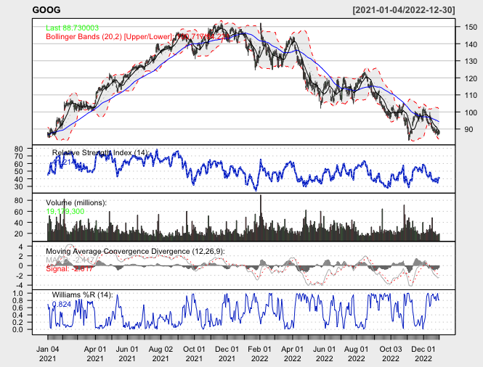

# Sentiment Analysis

For the analysis we have decided to use keywords to extract posts and comments data from Reddit to determine positive or negative reaction from the investors or the public, this would help to determine the public feeling and sentiment towards the company as a whole.

* Apple Text (main post): 0.030790706938406
* Apple Comments: 0.0551360853767936
* Google Text (main post): 0.105819283113585
* Google Comments: 0.0500421252193788

The graphs and word clouds are attached for sentimental analysis retrieved.

## Apple

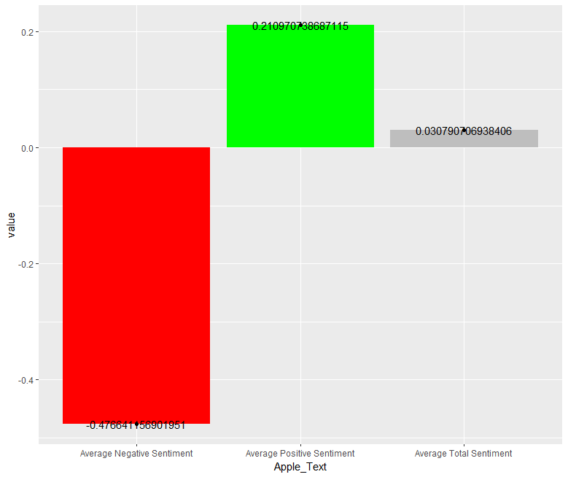 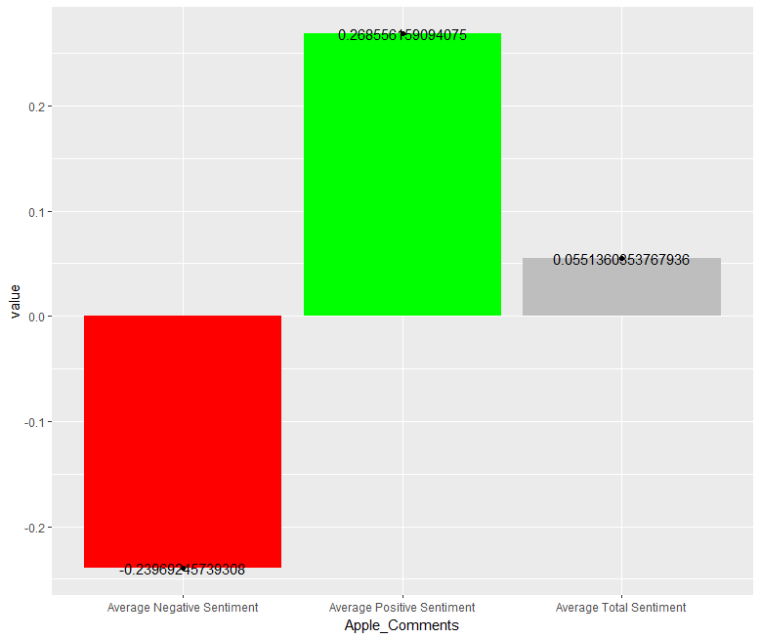

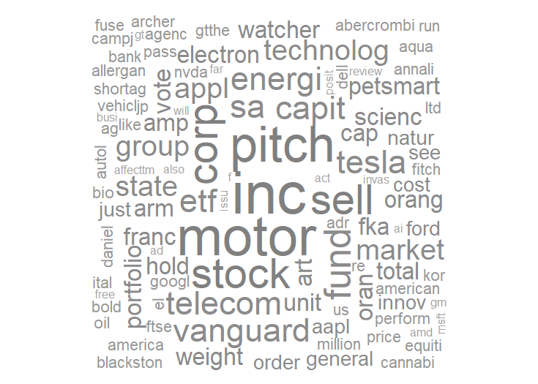

## Google

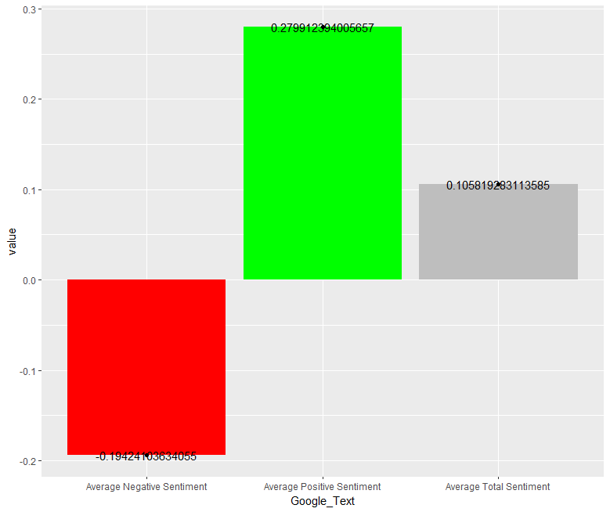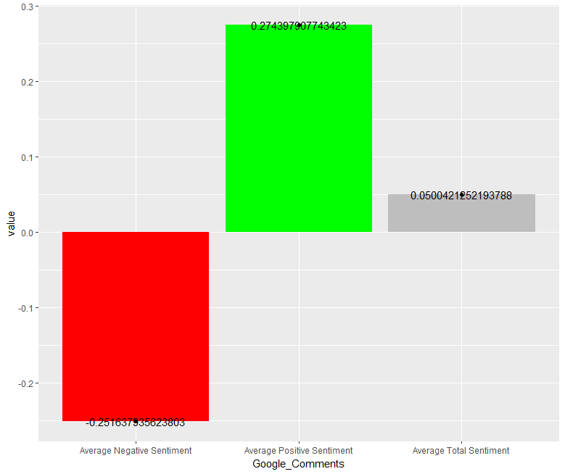

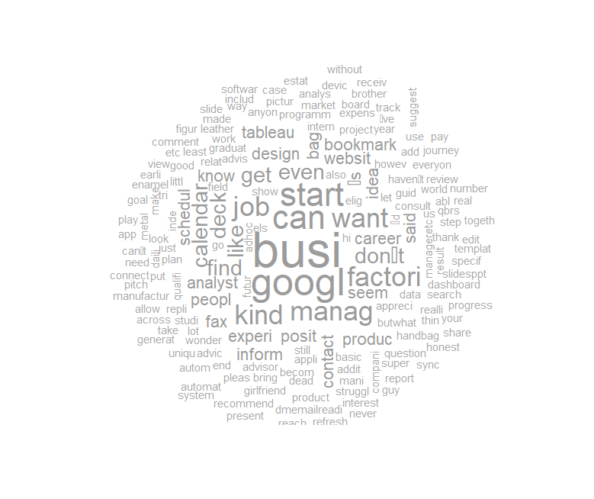

# alpha model

## Apple

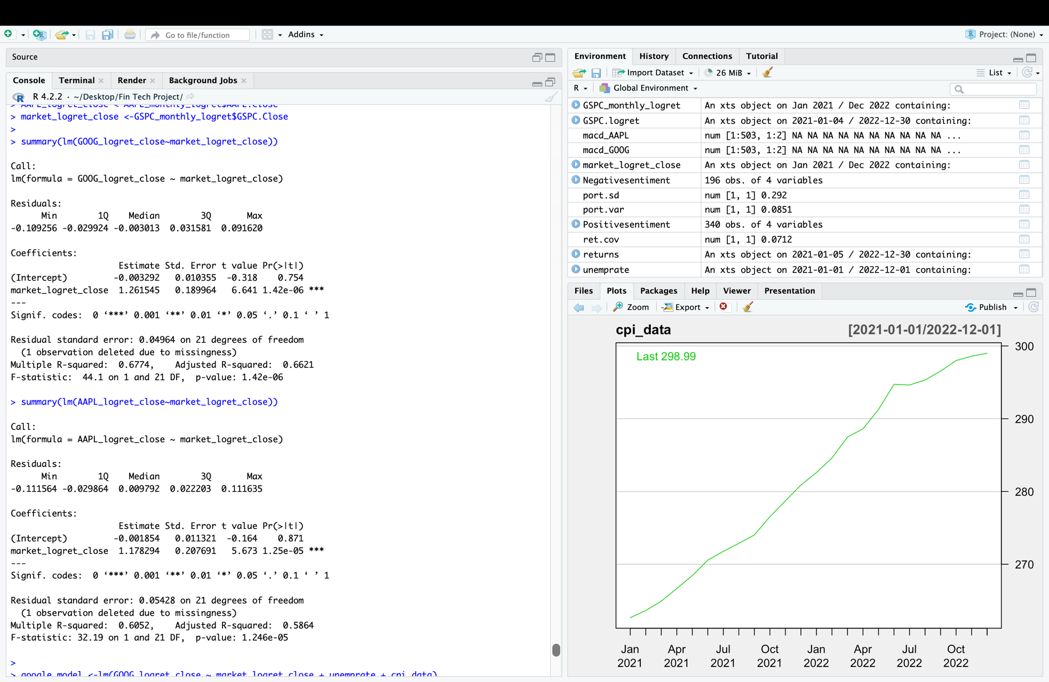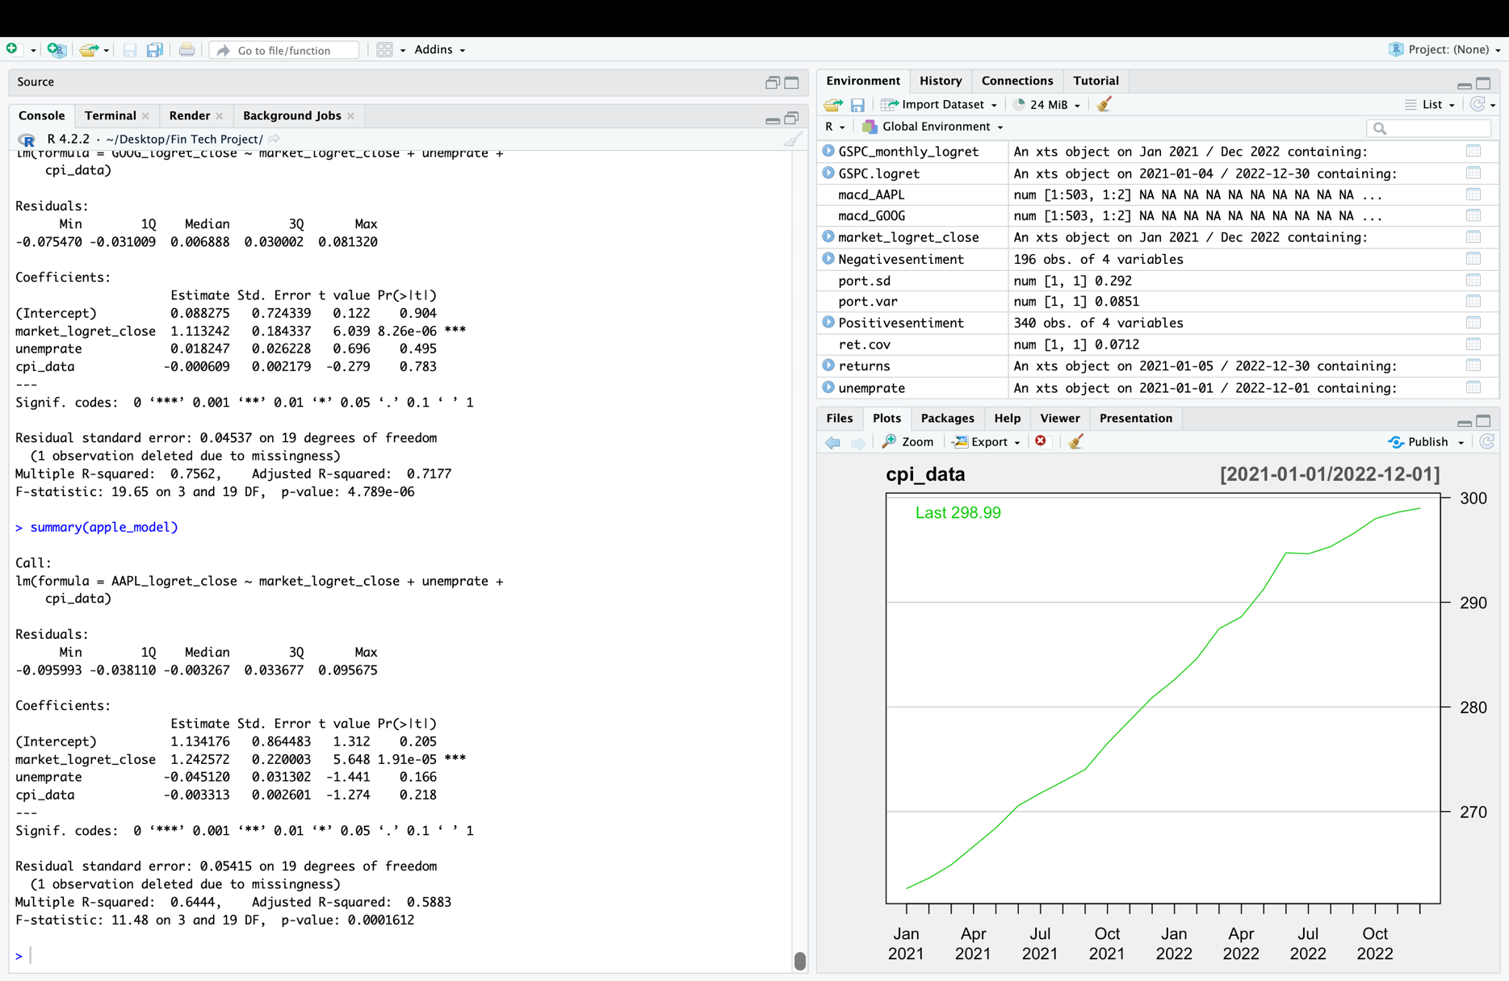

CAPM model claims that the value of alpha is near to 0 but generating negative alpha that is -0.001854 and market return(S&P500) i.e., beta is 1.178294

Apple%: Apple Returns + Market Returns + Un-employment Rate + Consumer Price Index = **2.328315**

## Google

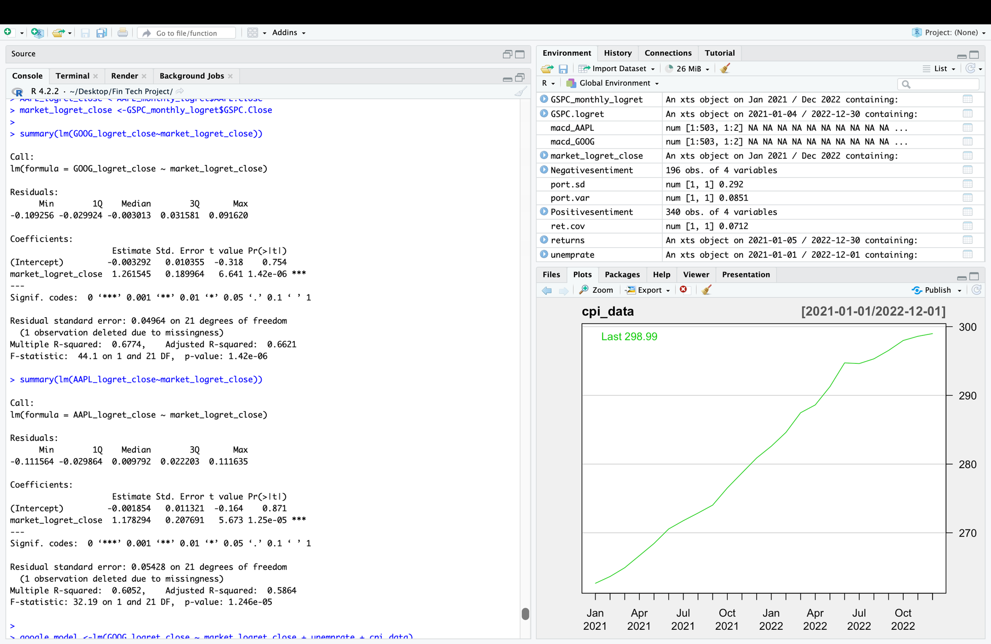 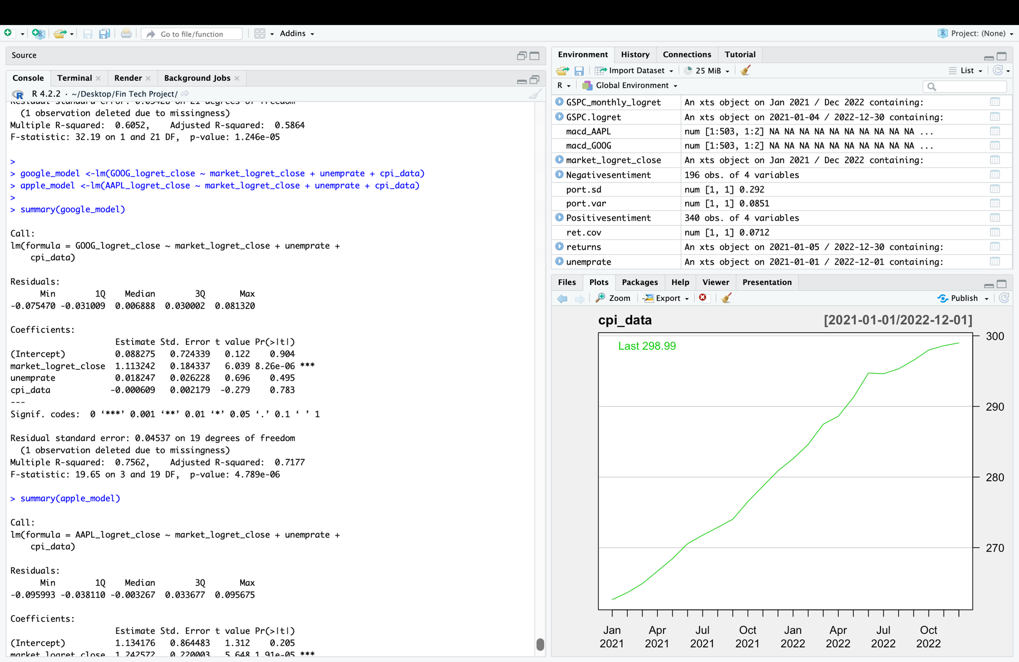

CAPM model claims that the value of alpha is near to 0 but generating negative alpha that is -0.003292 and market returns (S&P500) i.e., beta is 1.261545

Alphabet%: Google Returns + Market Returns + Un-employment Rate + Consumer Price Index = **1.219155**

# Conclusion

We conclude by recommending a short sale of Apple and Google's equities after doing a thorough examination utilizing a variety of methodologies, including sentimental analysis, a big data alpha model, fundamental analysis, and technical analysis. According to our study, the stock prices of both firms may soon decrease due to their current overvaluation. We advise against buying these stocks until the market gains momentum, as this would be a more advantageous time to enter the market.

We advise caution when investing in high-risk stocks like those of tech behemoths like Apple and Google because we believe that the market is inherently unpredictable. Our study shows that there is a strong likelihood that the market will trend downward soon, making now an unattractive time to buy the stocks. Hence, given the state of the market, it would be safer to sell these stocks short.

Overall, we think that our advice to short sell Apple and Google's equities and to buy the companies only once the market has gained momentum is a wise way to invest. We have offered a solid foundation for our advice by utilizing a variety of analytical techniques, and we anticipate that our analysis will be helpful in making wise investment decisions.

# bibliography

*Alphabet Investor Relations*. (n.d.). Alphabet Investor Relations. <https://abc.xyz/investor/>

Griffin, R. (2023, February 8). *How much will Apple stock be worth in 10 years?* Capital Com SV Investments Limited. <https://capital.com/apple-stock-price-in-10-years#:~:text=The%20Apple%20stock%20forecast%202030,by%20the%20end%20of%202025>.

*Investor Relations - Apple*. (n.d.). <https://investor.apple.com/investor-relations/default.aspx>

KRAUSE, R. (n.d.). *Is Google A Buy Amid Regulatory Headwinds, Artificial Intelligence Race?* www.investors.com. <https://www.investors.com/news/technology/google-stock-buy-now/>

*Yahoo is part of the Yahoo family of brands*. (n.d.). <https://finance.yahoo.com/quote/GOOG/>

# Thank You

## Submitted by Team 08

Sunal Sathvik Batchu – BXS220020

Harsha Mahanti – SXP220117

Chelluri Chiranjeevi Satya Abhisheik - CXC210077